Insert the below records in dept table

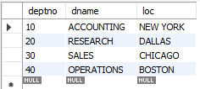

Insert the below records in emp table

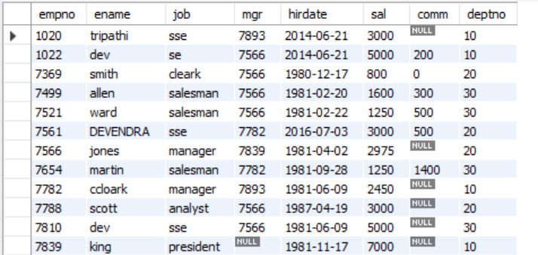

1. Write a query to retrieve the employee details who earn salary between 1250 and 5000 including range values
2. Fetch deptno, count of employees working in each department along with employee names.
3. Fetch the dept which consists of more than 3 employees.
4. Fetch the details of the employees who have char ‘e’ as second char in their name and earns more than 1000 and belongs to 10th or 20th dept and have comm more than 100.
5. Explain alter command and write all the possible syntaxes of alter command
6. Explain the difference between DDL and DML commands with example.
7. Fetch the dept and count of employees for each dept if employee earn more than 2000.
8. Explain the difference between primary key and composite primary key.
9. What is constraint and explain the types of constraint with example.
10. Difference between where and having clause.